**National University of Computer & Emerging Sciences**

**Karachi Campus**



**PAC-MAN: A NEXT-GENERATION ADAPTION**

**Project Proposal**

**OBJECT ORIENTED PROGRAMMING**

**Section: BCS-2A**

**Group Members:**

Shayan Aamir 23K-0623

Asad Hussain 23K-2002

Burhan Farooq 23K-0506

**Introduction:**

The aim of our project was to revitalize the classic Pac-Man game by introducing modern programming concepts and additional features to enhance gameplay. Inspired by the timeless appeal of the original, our motivation was to bring a fresh perspective to this iconic game while maintaining its nostalgic charm.

**Background:**

Before embarking on our project, we conducted thorough research into the history and mechanics of Pac-Man, analyzing its gameplay, design principles, and cultural significance. This research guided us in selecting Pac-Man as the base for our project, as we recognized its potential for adaptation and enhancement.

**Project Specification:**

Our project involved the development of a Pac-Man game using C++ and object-oriented programming (OOP) principles. We aimed to introduce novel features not present in the original game, such as advanced ghost tracking, new power-ups, and unique ghost behaviors. Additionally, we utilized libraries such as iostream, cmath, fstream, and raylib to implement various functionalities and graphical user interface (GUI) elements.

**Problem Analysis:**

The classic Pac-Man game, while beloved, lacked certain elements that could enhance its gameplay experience for modern audiences. Challenges such as simplistic ghost behavior and limited power-ups posed constraints on the game's depth and replayability. Addressing these limitations required a comprehensive analysis of the game mechanics and identification of areas for improvement.

**Solution Design:**

Our solution involved a detailed project design that incorporated advanced ghost AI algorithms, new power-up mechanics, and an enhanced user interface. Each ghost was programmed with unique characteristics, such as targeting specific positions relative to Pac-Man or exhibiting dynamic behavior based on proximity. Additionally, we introduced two new power-ups: one that eliminates all ghosts and another that allows Pac-Man to teleport in the direction of movement.

**Implementation & Testing:**

The implementation phase involved translating our design into code, utilizing C++ and relevant libraries to create the game mechanics and user interface. Rigorous testing was conducted to ensure the functionality and stability of the game, including unit testing for individual components and playtesting to evaluate gameplay balance and user experience.

**Project Breakdown:**

Grid Formation: All

Pacman Character: Shayan

Ghost Characters: Burhan & Asad

**Results:**

Screenshots of the game outputs showcase the graphical interface, gameplay mechanics, and various features implemented, demonstrating the successful realization of our project objectives.

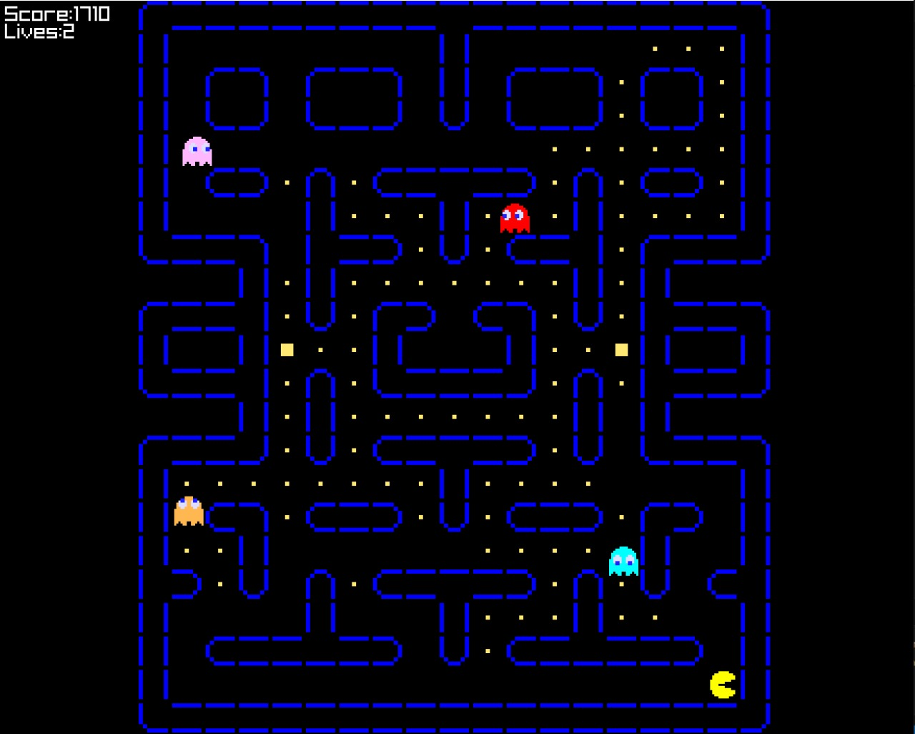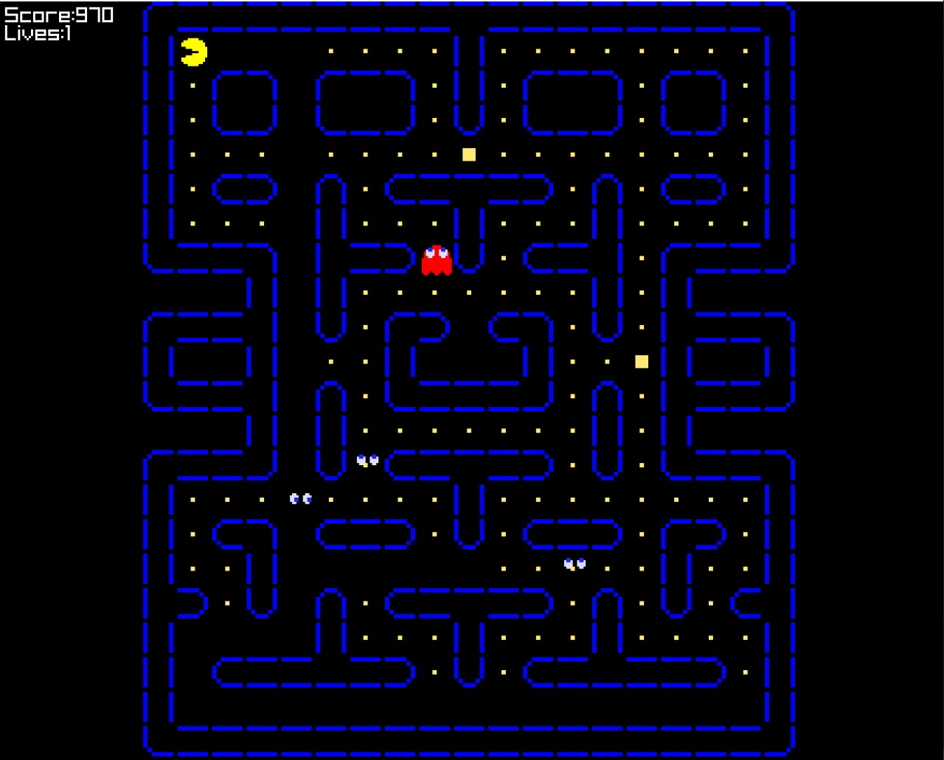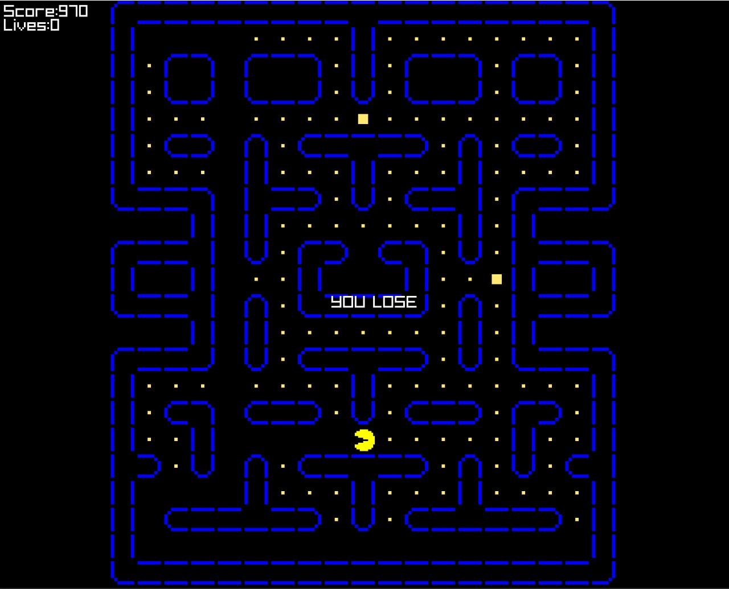

**Conclusion:**

In conclusion, our project succeeded in modernizing the classic Pac-Man game by introducing innovative features and leveraging advanced programming techniques. By enhancing gameplay depth and introducing new challenges, we aimed to appeal to both nostalgic fans and new audiences alike, offering a fresh take on a timeless classic.